Assignee Wise Summary
Path : Reports >> Assignee Wise Summary.
Steps to reach Assignee Wise Summary:
Step 1 : Reports in Steps to reach Assignee Wise Summary : Open the Reports module from the Billing Application(POS).
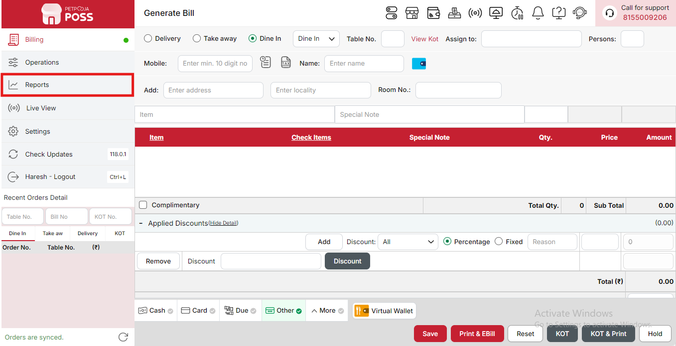
{Image Name: Reports Option,
Description: The red box highlights the “Reports” option in the sidebar menu. This section allows users to view and analyze various business reports, such as sales, billing, and order summaries, helping in effective tracking and decision-making.Here is an image of Step 1 Report in Steps to Reach Category Summary.}
Step 2 : Assignee Wise Summary in Steps to reach Assignee Wise Summary : Select Assignee Wise Summary to view sales, orders, and performance data categorized by assignees, helping track individual responsibilities and efficiency.
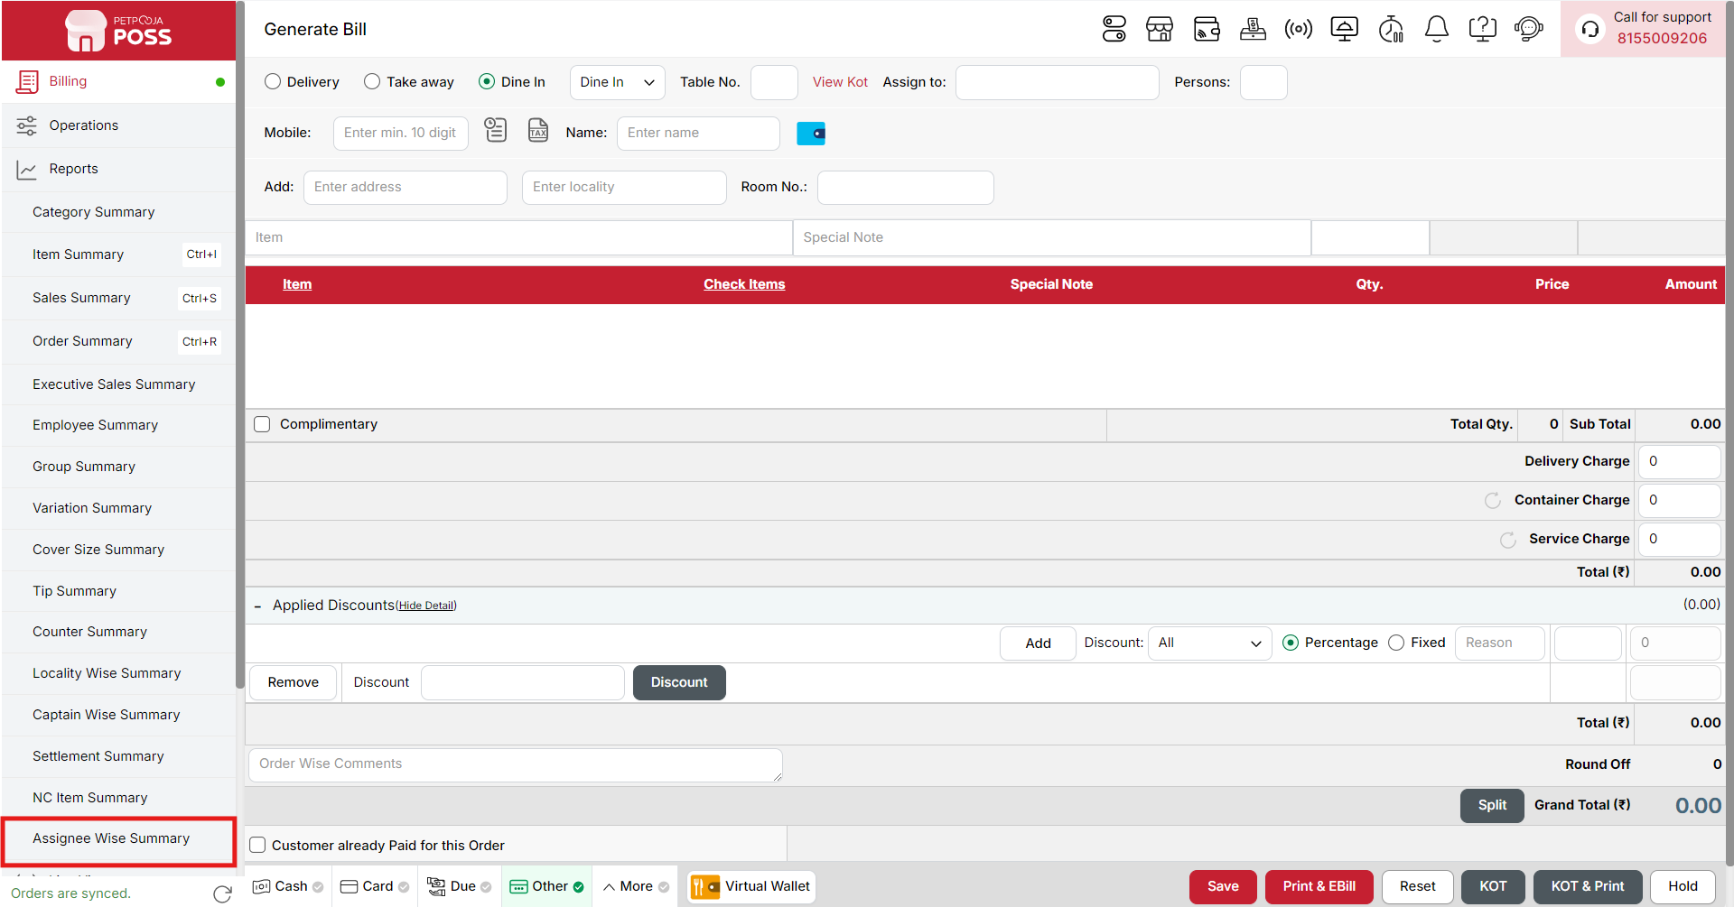
{Image Name: Assignee Wise Summary,
Description: The red box highlights the Assignee Wise Summary option under the Reports section. This report provides a detailed breakdown of sales or orders based on the assigned staff or users, enabling management to evaluate employee performance, monitor workload, and ensure accountability in operations.Here is an image of Step 2 Assignee Wise Summary in Steps to Reach Assignee Wise Summary.}

Key features of Assignee Wise Summary :
(Assignee Wise Summary) Note: If you are not able to see or use the Assignee Wise Summary option in your billing application, it means that you do not have the required permission. To enable this, you need to go to the Owner Dashboard and open the User Management section. Inside User Management, you will find a permission called Assignee Wise Summary Show Button — you must checkmark this option to give access.If you are not able to view old day reports, then you also need to enable the Days Restriction permission. Inside the same User Management section, select No Restriction so that you can view reports for any date.After allowing these permissions, perform a manual sync so the system updates the rights properly. Once the sync is done, log out from the billing application and then log in again. After this process, the Assignee Wise Summary option will become visible, and you will be able to view all reports without any problem.

- (Assignee Wise Summary) Assignee Wise Summary: Displays a complete overview of all orders and payments managed by each assignee. This helps in assessing staff productivity and accountability for both order handling and payment collection.
- (Assignee Wise Summary) Assignee: Represents the name and role of the staff member responsible for managing the orders, such as a captain, waiter, or billing user (e.g., “Gaurav – Captain”).
- (Assignee Wise Summary) Orders Punched: Shows the total number of orders entered or initiated by the assignee during the selected period, reflecting their overall activity.
- (Assignee Wise Summary) Orders Success: Displays the total number of successfully completed and billed orders handled by the assignee.
- (Assignee Wise Summary) Orders Cancelled: Indicates the number of orders that were cancelled after creation by the assignee.
- (Assignee Wise Summary) Orders Discounted: Shows the count of orders on which the assignee applied discounts, including offers, coupons, or manual adjustments.
- (Assignee Wise Summary) Orders Modified: Represents the total number of orders edited or updated by the assignee after initial entry, such as changes in quantity, items, or order details.
- (Assignee Wise Summary) Orders Reprinted: Displays how many times the assignee reprinted order bills, helping track reprint activity.
- (Assignee Wise Summary) Payment Type: Shows the various modes of payment used for transactions handled by the assignee, such as Cash, Card, Due Payment, Other, Wallet, Online Paid, and Online COD.
- (Assignee Wise Summary) Total (₹): Displays the total value of transactions processed under each payment type, providing a detailed view of payment collection by the assignee.
- (Assignee Wise Summary) Sub Total: Shows the sum of all payments received by the assignee across all payment modes for the selected day, giving a complete overview of their total handled revenue.
Search Button (Assignee Wise Summary) : The Search button is used to find the report for a specific date or time. It helps you quickly see sales details for the selected period. After choosing the date or time, you can click on Search to view the report.
- From (Assignee Wise Summary) : The From option is used to select the starting date for the assignee-wise report. It means the report will begin from this date.
- To (Assignee Wise Summary) : The To option is used to select the ending date for the assignee-wise report. It means the report will show data up to this date.
- Employee (Assignee Wise Summary) : The Employee option allows you to select the employee (assignee) for whom you want to view the report. After selecting the employee, you can see detailed data for that specific person within the selected date range.
- Time Wise Option (Assignee Wise Summary) : The Time Wise Option is used when you want to see the report for a specific time period within a day. After turning it ON, you can choose both date and time — for example, from 10:00 AM to 5:00 PM — to see sales during that time. If you keep this option OFF (Without Time Wise Option), then the report will show the whole day’s data for the selected date range without filtering by time.
(Assignee Wise Summary) Print Button: The Print Button is used to print the report. If you want to take a printout of the report, you just need to click on the Print button.
If you get an error saying “Please assign one printer for report print”, then follow these steps:
- Go to Operation → Bill/KOT Print → Multiple Printer Settings.
- Select and edit one printer that you want to use for printing the report.
- In that printer setting, there is an option called “Use this printer for report print”.
- Check this box and save the setting.
After doing this, you will be able to print the report successfully using the selected printer.
(Assignee Wise Summary) Print Configuration: This section is used to set how your report will look when you print it. You can change the format, size, and what details to show on the printed page.
- (Print Configuration) Format Preference: Used to select the layout or design of the printed report.
- (Print Configuration) Show Bill Header: If you check this option, the header (top part with company or shop name) will appear on the print.
- (Print Configuration) Show Bill Footer: If you check this option, the footer (bottom part with notes or messages) will appear on the printed report.
- (Print Configuration) NONE: Select this option if you don’t want to apply any specific print format or layout. The report will print in the default basic format without additional formatting or sections.
- (Print Configuration) Display To Date on Print: If you check this option, the “To Date” of the report will be shown on the printed page.
- (Print Configuration) Display Time on Print: If you check this option, the time will be displayed on the print along with the date.
- (Print Configuration) Display Summary Box on Print: If you check this option, a summary box will appear at the end of the report showing total amounts and other summary details.
- (Print Configuration) Display Print Date & Time on Print: If you check this option, the date and time when the report was printed will appear on the print.
- (Print Configuration) Main Width: Used to set the width of the report on the printed page. For example, 500 means the report will be printed with that width size.
- (Print Configuration) Font Size: Used to set the text size of the printed report. You can increase or decrease it as needed.
- (Print Configuration) Cancel: Click this button to close the print configuration window without saving any changes.
- (Print Configuration) Save:Click this button to save all the changes you made in the print configuration settings.
(Assignee Wise Summary) Export Excel: If you want to download or save the report in Excel format, you have to click on the Export Excel button. This will create an Excel file of the report that you can open and use in Microsoft Excel.

